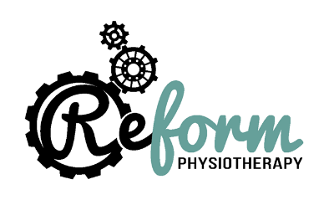

COVID 19 Physiotherapy consent form

As a result of COVID-19 we have had to take a variety of measures to ensure your safety and the safety of our staff and now also need to make sure you are happy to receive advice and treatment in person. Considering this, please complete and sign this form below prior to treatment.
I, _____________________________, knowingly and willingly consent to receive Physiotherapy services performed at Reform Physio during the COVID-19 pandemic. The transmission of COVID-19 is thought to occur mainly through respiratory droplets generated by coughing and sneezing, and through contact with contaminated surfaces. (Public Health England)
I understand the COVID-19 virus has a long incubation period during which carriers of the virus may not show symptoms and still be contagious. It is impossible to determine who is infected and who is not, given the current limits in virus testing. _________ (initials)
Although Reform Physio is taking significant steps to ensure patient safety (outlined below) I understand that due to the characteristics of the virus, and the characteristics of Physiotherapy services, that I have an elevated risk of contracting the virus by attending the clinic, ________(initial)
Steps taken:
- 15 minutes between appointments to prevent patient to patient contact and to ensure thorough cleaning of the clinic.
- Full use of Personal Protective Equipment (PPE) by the clinician, including gloves, plastic gown and surgical mask
- All patients will also be asked to wash their hands thoroughly prior to the appointment and asked to wear a mask that will be provided.
I confirm that I am not presenting with and have not had any of the following symptoms of COVID-19 within the past 14 days or been in contact with anyone with these symptoms: ________(initial)
• Fever – temperature over 37.8C
• Shortness of breath
• Loss of sense of taste or smell
• New continuous cough

We ask that anyone coming for treatment check their temperature prior to visiting the clinic and if higher than 37.8C please call the clinic and discuss alternative treatment options.
I understand, have read, and completed this questionnaire truthfully. I agree that this constitutes full disclosure and that it supersedes any previous verbal or written disclosures. I understand that this document is to provide the safest possible visit to Reform Physio.

Patient name:_____________________________
Signature: ________________________________
Today’s date: ___________

